Ansible Challenge

Create ci pipeline that will deploy and configure these VMs using terraform and ansible according following requirements
- Deploy 2 virtual machines using terraform.
  - first vm on Amazon linux, hostname: c8.local
  - second vm on ubuntu 21.04, hostname: u21.local
- As a result of terraform execution, dynamically create inventory for ansible
  - c8.local should be in the frontend group
  - u21.local should be in the backend group
- Create ansible playbook for c8.local and u21.local
- for linux OS playbook should apply the following changes
  - selinux: disable
  - firewalld: disable
- for frontend playbook group should install and configure nginx
  - nginx configuration should do proxying from port 80 on port 19999 to the
  - backend group
- for the backend group, the playbook must install the Netdata application from the
  - official repositories and run it on port 19999.

Open the Jenkins srever:
TERRAFORM-VERSION CHECK
terraform --version
Output shows:
- Terraform v1.14.3 installed
- Warning: latest is 1.14.4

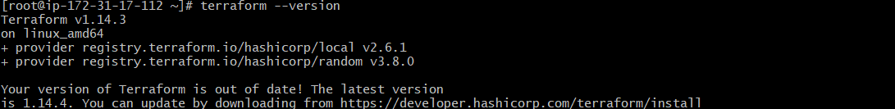

Installing Ansible (Amazon Linux)
yum install ansible
It installed:
- ansible-core
- python dependencies
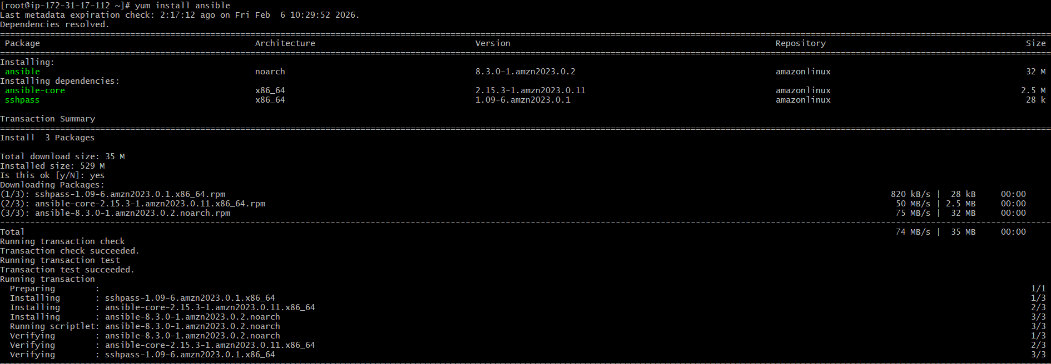

Installing Docker
yum install docker
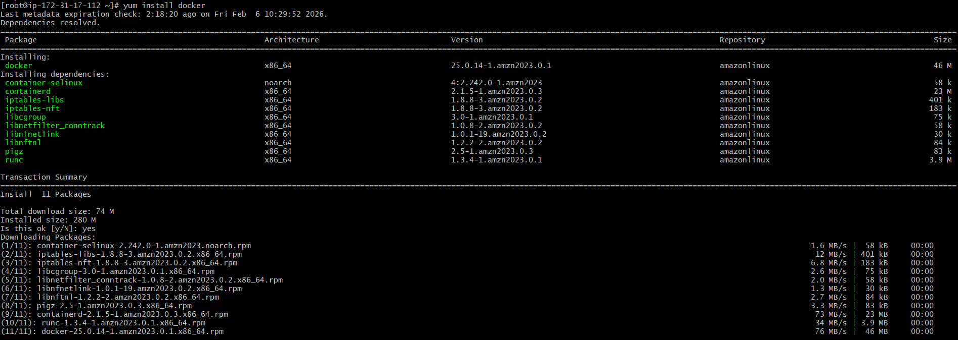

Jenkins Plugin (AWS Credentials Plugin)
In Jenkins UI → Manage Jenkins → Plugins
You searched and installed:
AWS Credentials Plugin

This plugin allows Jenkins to store AWS Access Key securely and use it in pipelines.
Without this plugin, Jenkins cannot directly authenticate to AWS using IAM keys.

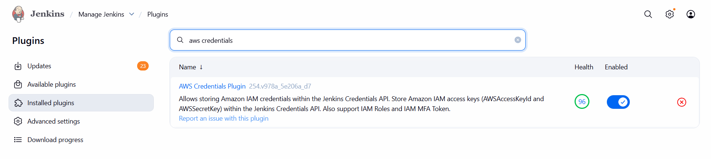

Jenkins AWS Credentials Added
You added AWS key in Jenkins:
- ID: aws-key
- Access Key ID: AKIA...
- Secret Key: hidden
Now Jenkins can run Terraform commands using AWS credentials securely.

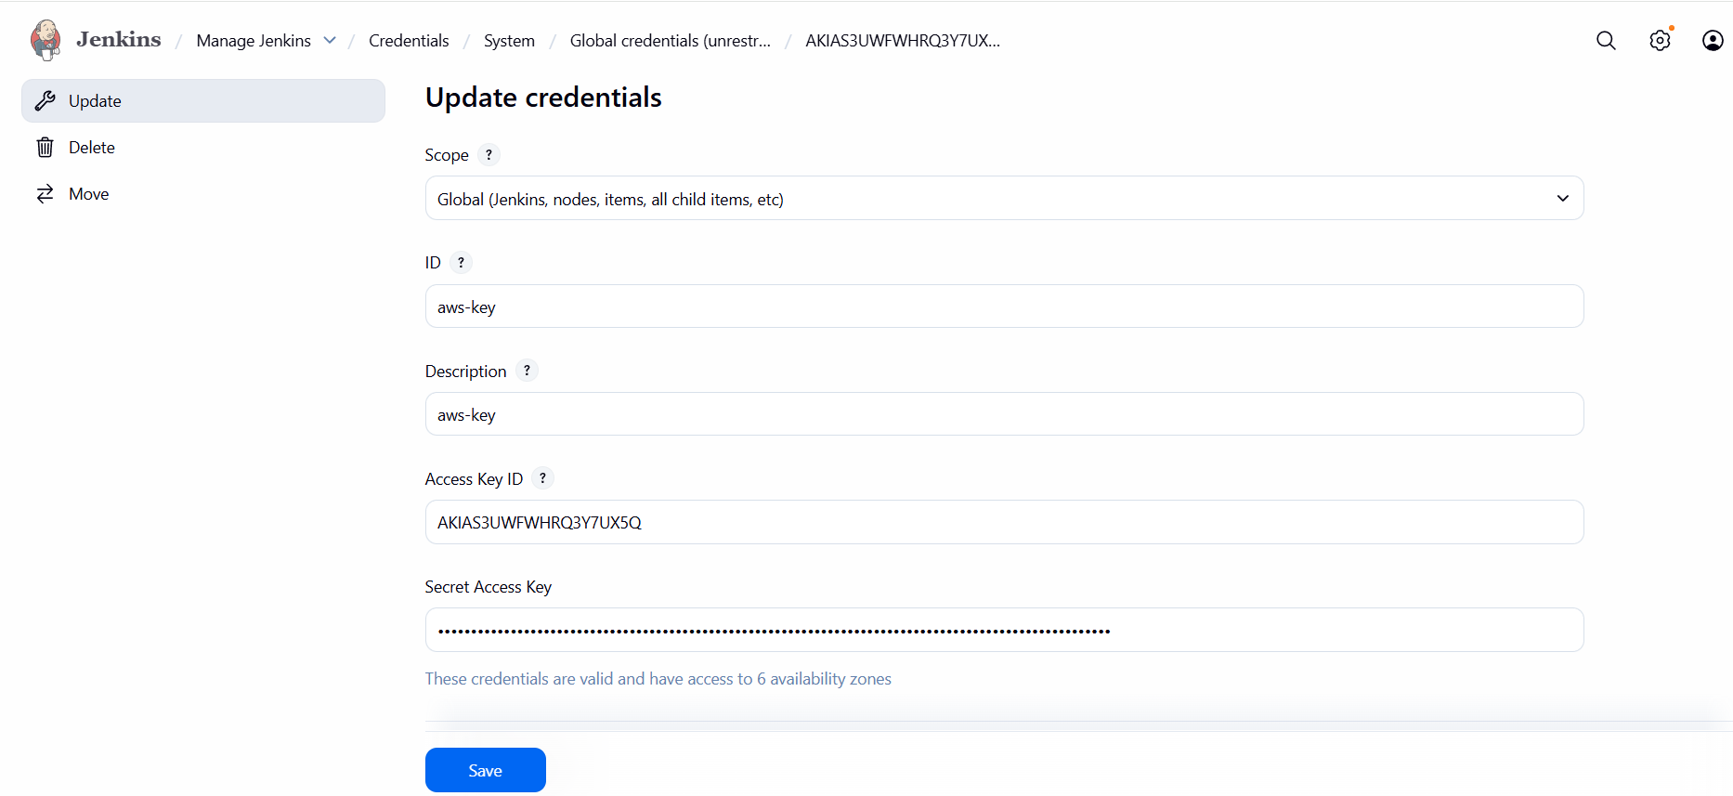
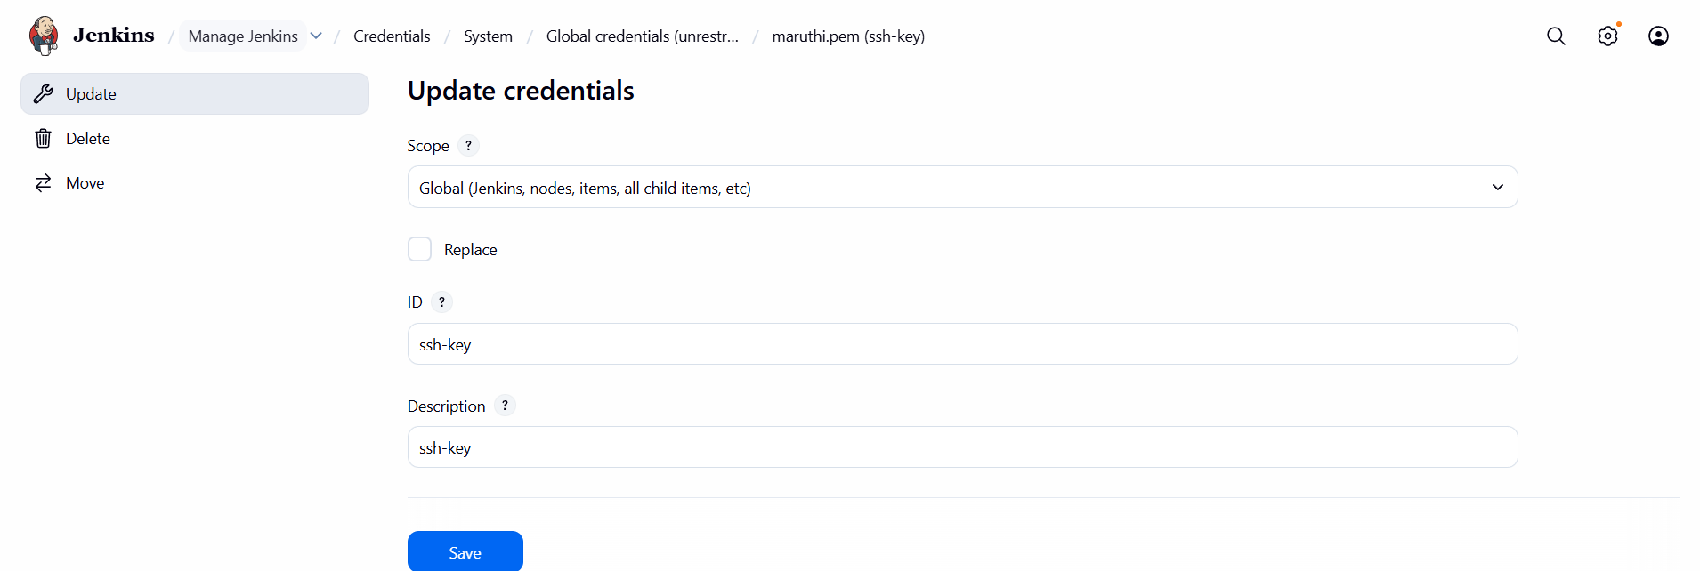

SSH Key Credential Added in Jenkins
You added PEM key (maruthi.pem) into Jenkins credentials.
- ID: ssh-key
- Type: SSH private key
This is required for Ansible to connect to EC2 instances.
Ansible needs the private key to SSH into:
- c8.local
- u21.local
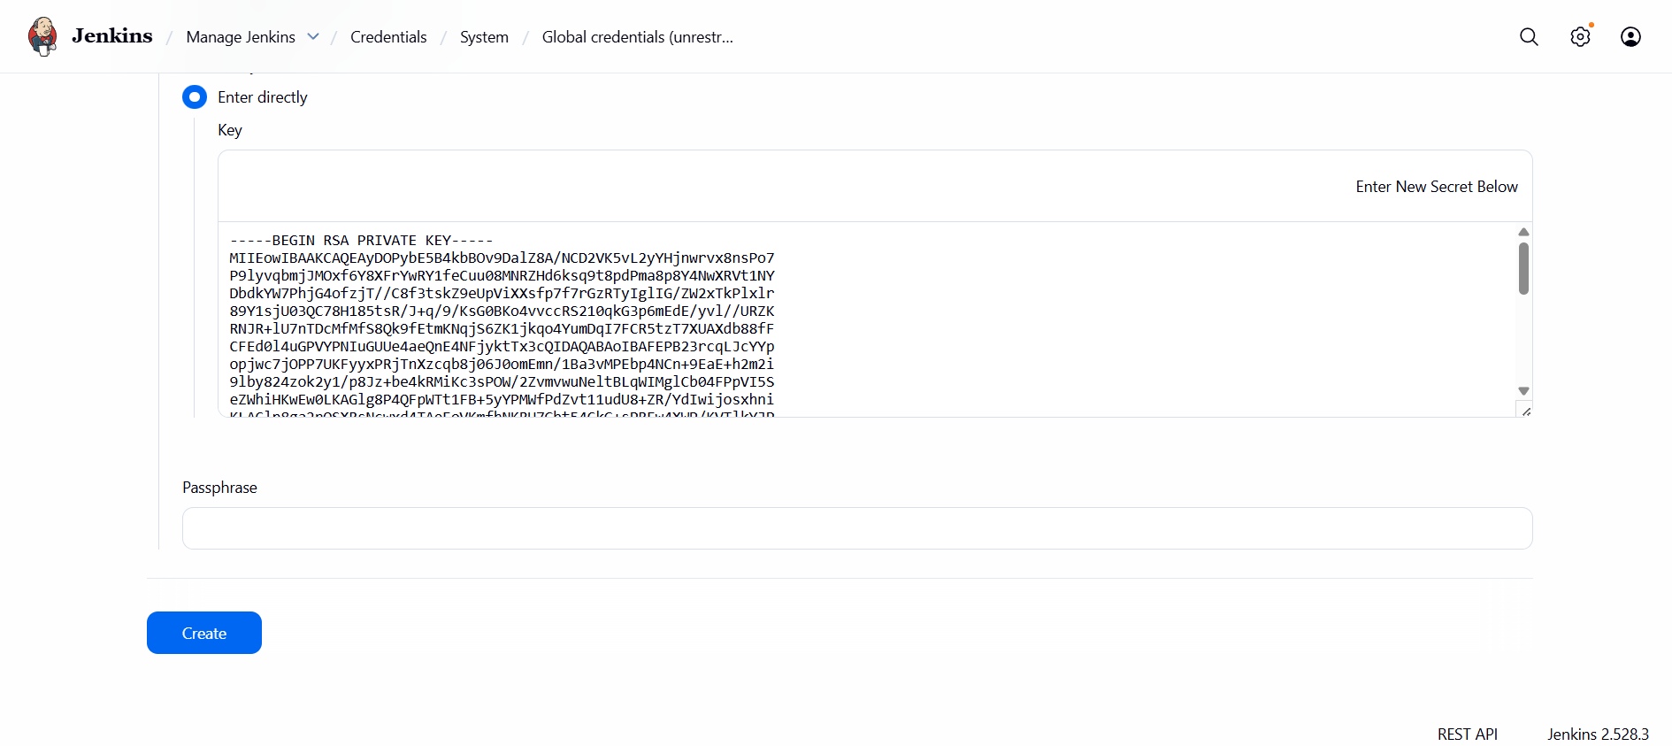

Jenkins Credentials List
It shows both credentials stored:
aws-key
ssh-key
Now Jenkins has both:
- AWS authentication (for Terraform)
- SSH authentication (for Ansible)

GitHub Repo with Jenkinsfile
You uploaded Jenkinsfile in GitHub repo.
It includes pipeline stages like:
- Checkout
- Terraform Apply
- Ansible Deploy
Jenkins will fetch this Jenkinsfile and execute pipeline automatically.

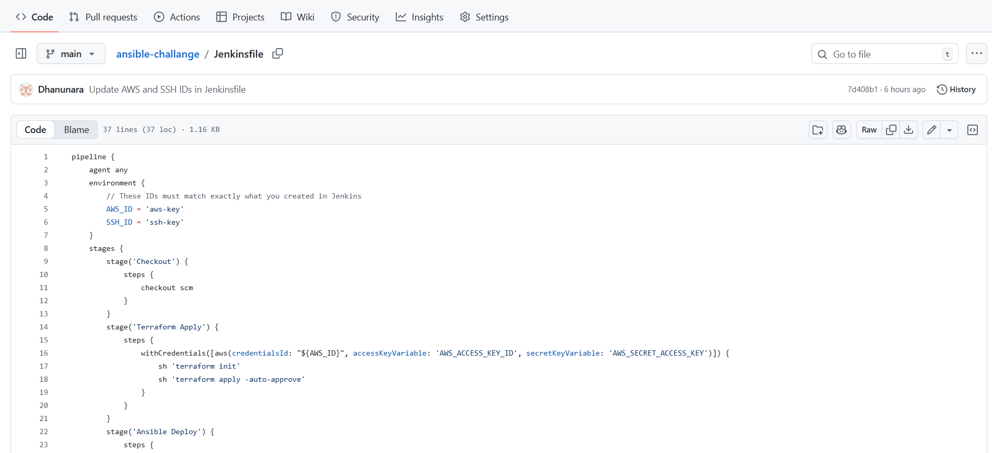

Terraform main.tf file in GitHub
This file contains Terraform code which creates EC2 instances.
Your code shows:
- provider AWS
- resource aws_instance amazon_linux_vm
- resource aws_instance ubuntu_vm
And also hostname setting using user_data.
Terraform will create:
- Amazon Linux instance named c8.local
- Ubuntu instance named u21.local

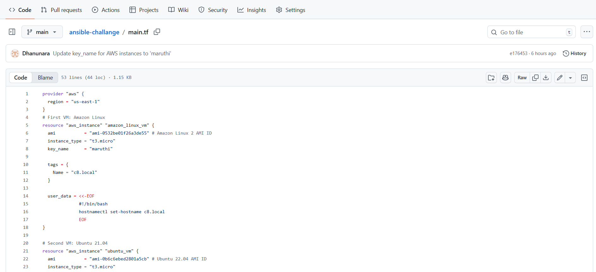

Jenkins Job Configuration Page
You selected Pipeline and set:
- Script Path: Jenkinsfile
- Lightweight checkout enabled

Meaning:
Jenkins will read Jenkinsfile from your repo and execute pipeline.

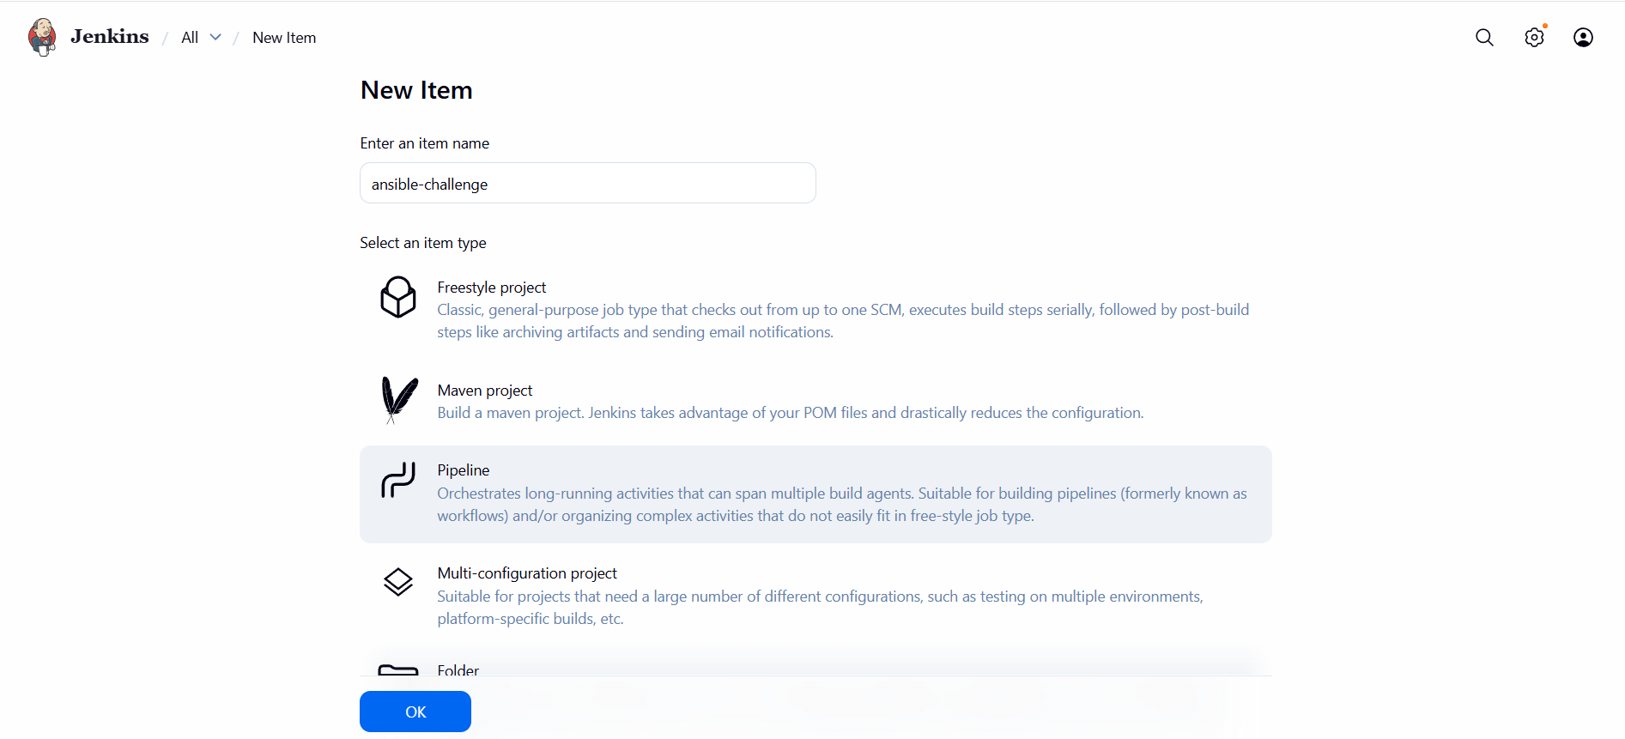
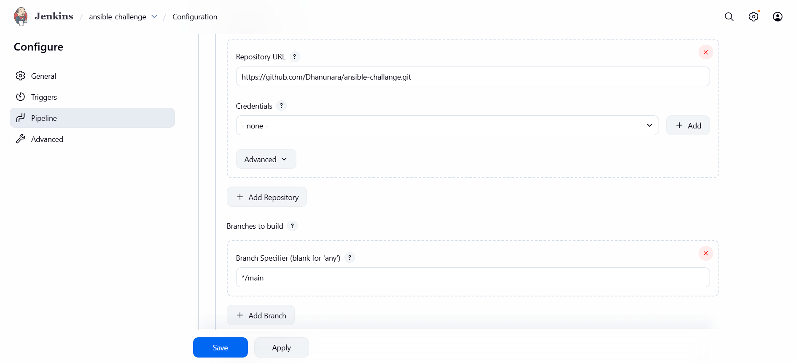
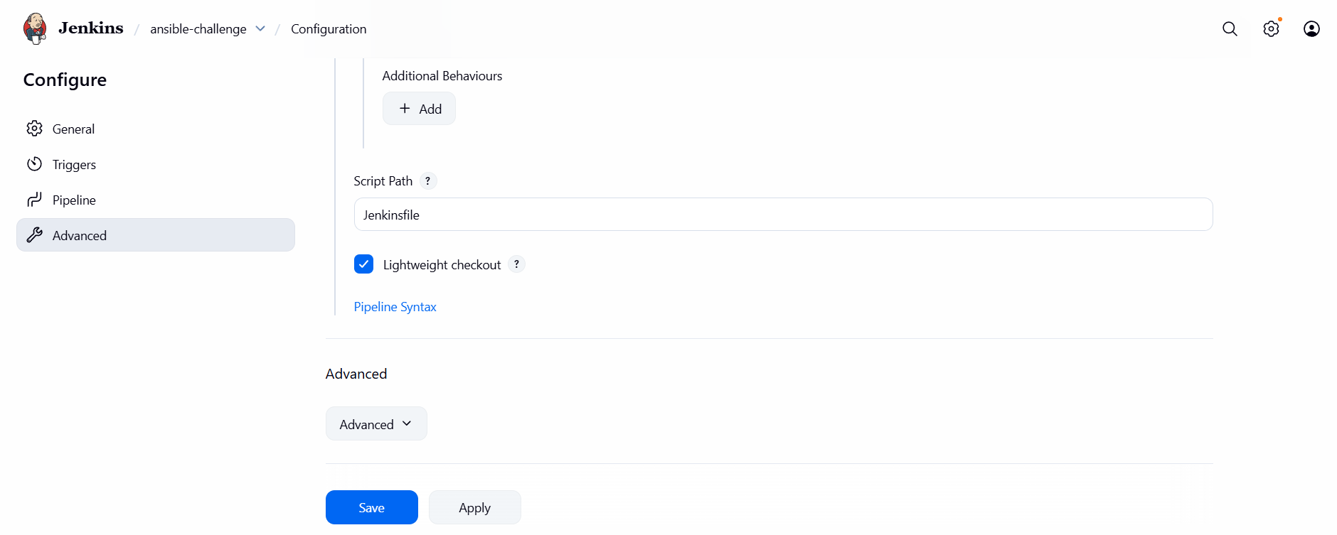

Jenkinsfile
pipeline {
agent any
environment {
// These IDs must match exactly what you created in Jenkins
AWS_ID = 'aws-key'
SSH_ID = 'ssh-key'
}
stages {
stage('Checkout') {
steps {
checkout scm
}
}
stage('Terraform Apply') {
steps {
withCredentials([aws(credentialsId: "${AWS_ID}", accessKeyVariable: 'AWS_ACCESS_KEY_ID', secretKeyVariable: 'AWS_SECRET_ACCESS_KEY')]) {
sh 'terraform init'
sh 'terraform apply -auto-approve'
}
}
}
stage('Ansible Deploy') {
steps {
echo "Waiting for instances to initialize..."
sleep 45
withCredentials([file(credentialsId: "${SSH_ID}", variable: 'SSH_KEY_PATH')]) {
sh "ansible-playbook -i inventory.ini setup.yml --private-key ${SSH_KEY_PATH} --ssh-common-args='-o StrictHostKeyChecking=no'"
}
}
}
}
post {
success {
echo "Deployment successful! Access the frontend IP on port 80."
}
}
}

Main.tf
provider "aws" {
region = "us-east-1"
}
# First VM: Amazon Linux
resource "aws_instance" "amazon_linux_vm" {
ami = "ami-0532be01f26a3de55" # Amazon Linux 2 AMI ID
instance_type = "t3.micro"
key_name = "maruthi"

tags = {
Name = "c8.local"
}

user_data = <<-EOF
#!/bin/bash
hostnamectl set-hostname c8.local
EOF
}

# Second VM: Ubuntu 21.04
resource "aws_instance" "ubuntu_vm" {
ami = "ami-0b6c6ebed2801a5cb" # Ubuntu 22.04 AMI ID
instance_type = "t3.micro"
key_name = "maruthi"

tags = {
Name = "u21.local"
}

user_data = <<-EOF
#!/bin/bash
hostnamectl set-hostname u21.local
EOF
}

output "frontend_ip" {
value = aws_instance.amazon_linux_vm.public_ip
}

output "backend_ip" {
value = aws_instance.ubuntu_vm.public_ip
}

resource "local_file" "ansible_inventory" {
filename = "inventory.ini"
content = <<-EOT
[frontend]
c8.local ansible_host=${aws_instance.amazon_linux_vm.public_ip} ansible_user=ec2-user

[backend]
u21.local ansible_host=${aws_instance.ubuntu_vm.public_ip} ansible_user=ubuntu
EOT
}
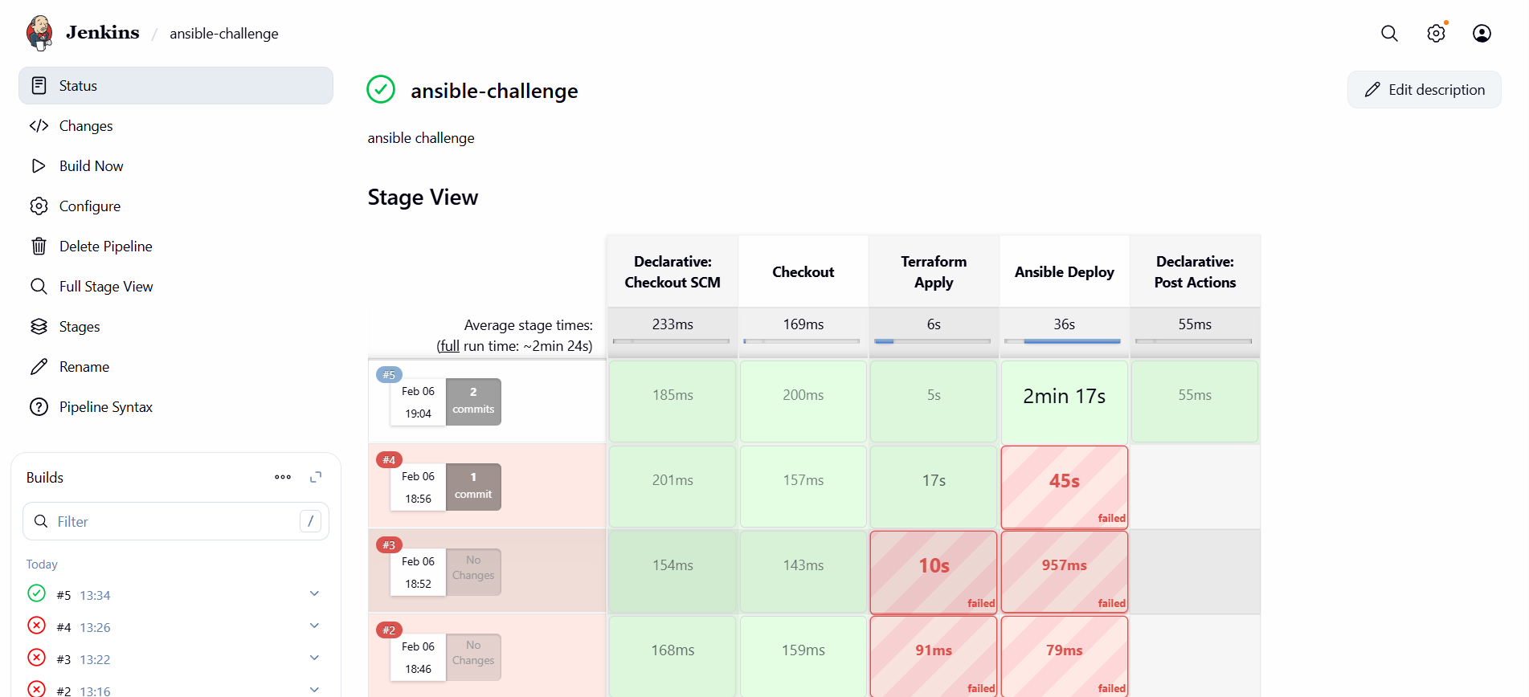

AWS Security Group Inbound Rules
You opened inbound rules and allowed ports:
- 8080 (Jenkins)
- 19999 (Netdata)
- 22 (SSH)
- 80 (HTTP)
- 81 (custom maybe testing)

Meaning:
This is mandatory because:
- Jenkins UI runs on 8080
- Netdata runs on 19999
- Nginx runs on 80
- SSH on 22
So browser can access Jenkins + Netdata + Nginx.

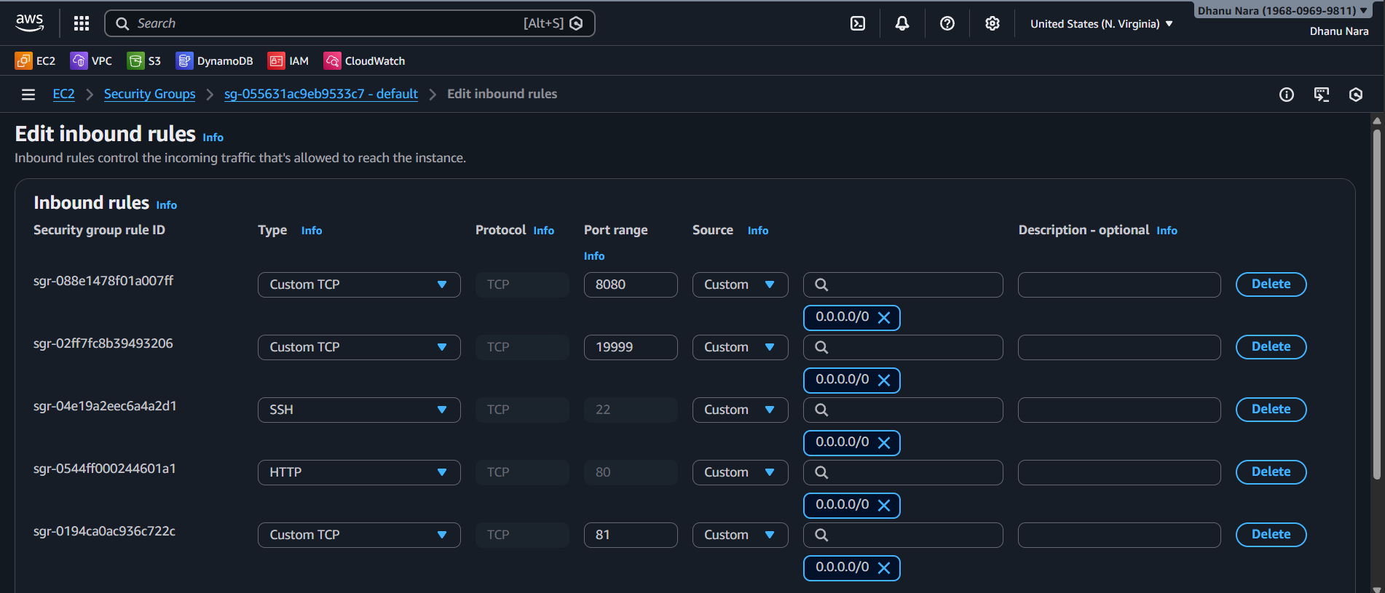

Netdata Dashboard Opened in Browser

http://<ip>:19999

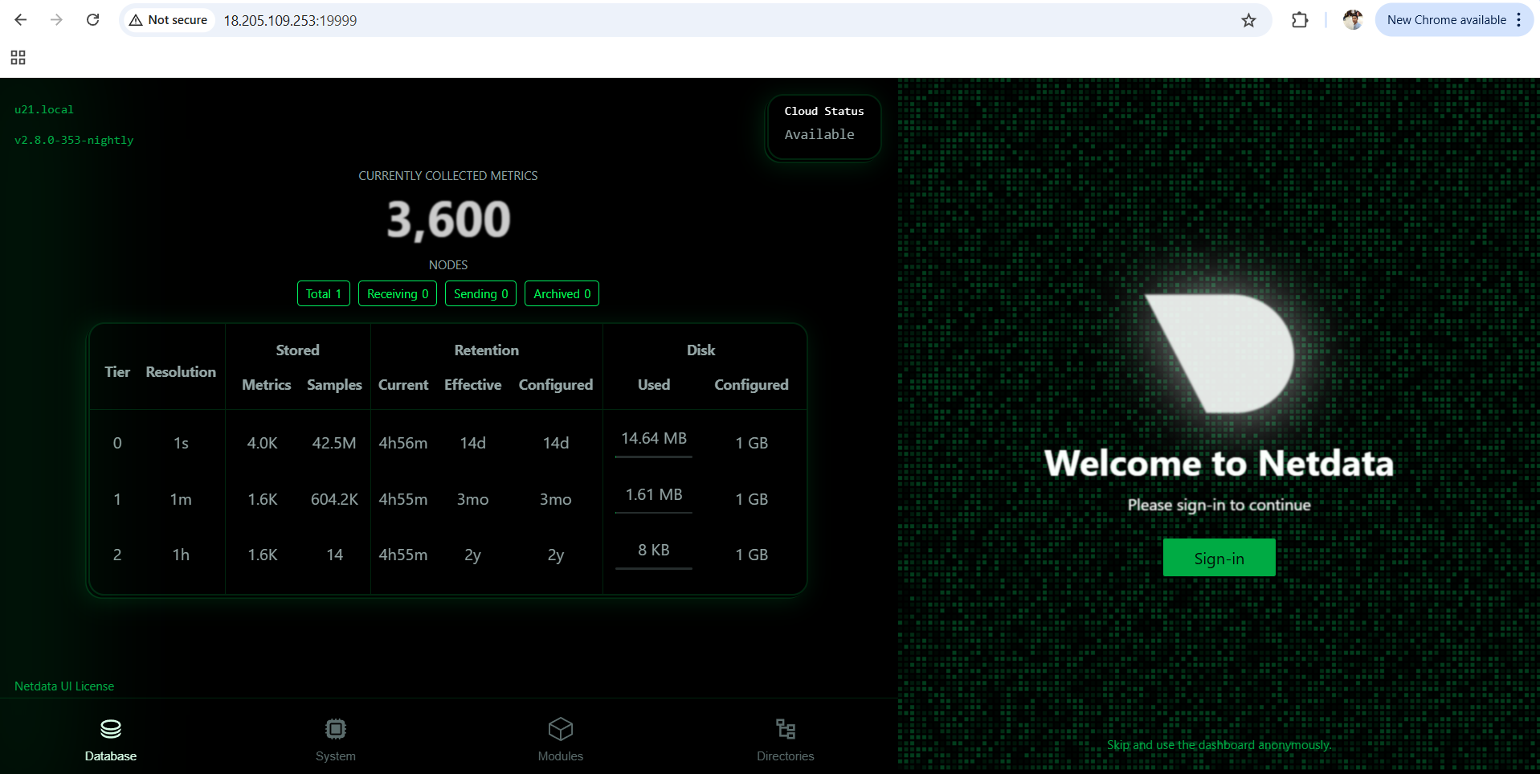
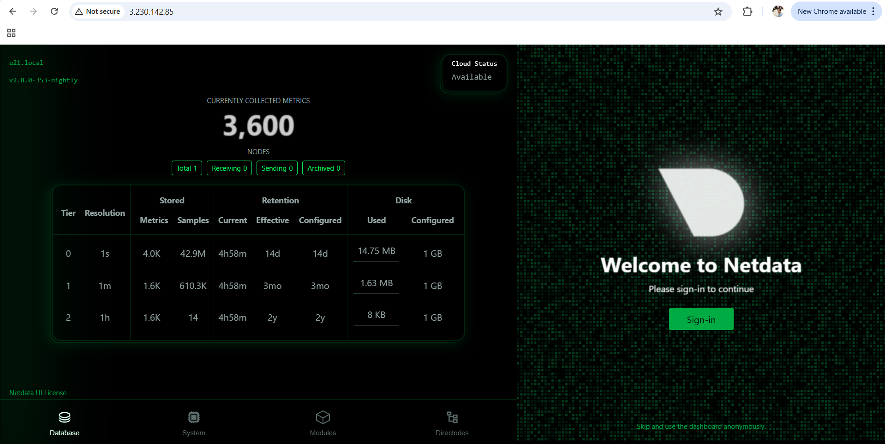

PIPELINE FLOW
This is what happens when you click Build Now in Jenkins:

Stage 1: Checkout Code
Jenkins pulls your repo from GitHub:
- Jenkinsfile
- main.tf
- ansible playbooks

Stage 2: Terraform Apply
Terraform creates 2 instances:
- Amazon Linux VM (c8.local)
- Ubuntu VM (u21.local)
Also it assigns public IPs.

Stage 3: Dynamic Inventory Creation
After Terraform completes, Jenkins extracts public IP addresses from Terraform output.
Then Jenkins creates an inventory file like:
[frontend]
c8.local ansible_host=<amazon-linux-ip> ansible_user=ec2-user

[backend]
u21.local ansible_host=<ubuntu-ip> ansible_user=ubuntu

Meaning:
Inventory is automatically generated.
No manual entry required.

Stage 4: Ansible Deployment
Jenkins runs Ansible playbook:
- Disable SELinux
- Disable firewalld
- Install Nginx on frontend
- Configure Nginx proxy
- Install Netdata on backend
- Start Netdata service

Stage 5: Output and Success
Once pipeline finishes successfully:
- Backend Netdata works on port 19999
- Frontend Nginx works on port 80
- Nginx proxies traffic to backend

WHY NGINX PROXYING IS USED
Because requirement says:
Frontend should proxy from:
port 80 ---> backend:19999
So instead of users typing:
http://backend-ip:19999
Users can access Netdata easily from frontend:
http://frontend-ip
That’s real-world architecture: frontend acts as reverse proxy.

